|  |
| --- |
| e-PG Pathshala logo.png  **Information Technology** |
| **Mobile Computing** |
| **Module: Signal Propagation Effects** |

## **Learning Objectives**

* Signal definition
* Modes of signal propagation
  + Ground wave propagation
  + Sky wave propagation
  + LOS propagation
* Phenomena effecting signal
  + Reflection, Refraction, Diffraction, Scattering
* Effects on signal due to phenomena
  + Multipath propagation, Delay spread, inter symbol interference

## **Introduction**

In the previous modules we learnt what is wireless communication, different modes of wireless communication, how data and voice travel in the form of signals, which of electromagnetic spectrum are used for wireless communication, frequencies used for different wireless technologies. When E.M. waves carry data in the form of voice, images etc. it is known as signal. Signal on its way from sender to receiver is effected by several factors like distance as well as the environmental objects it interacts with. According to the properties of the object, earth’s atmosphere and wavelength of signal, the signal undergoes different phenomena like reflection, refraction, diffraction and scattering. Due to these phenomena, various effects occur which destructively or constructively effect the communication. In this module, we will learn about these phenomena and the effects due to them.

## **Signal**

The physical representation of data by the transmission of which communication takes place is known as signal. The representation can be electrical, electronic or optical. Voice, images, letters or numbers can be represented using signals. Signal can be analog or digital.

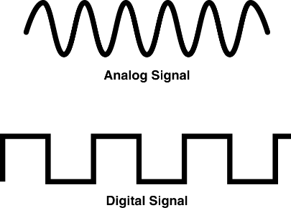

Figure 1 Analog Signal v/s Digital signal

## **Factors affecting strength and path of EM waves**

* Distance between transmitter and receiver
* Frequency/wavelength of wave
* Earth’s atmosphere
* Environmental objects

## **Signal Propagation modes**

A signal on its journey from transmitter to receiver propagates in three modes. Type of Propagation is determined by the carrier frequency.

* Ground waves or surface waves propagation
* Sky waves or Ionospheric propagation
* Space waves or Line-of-sight propagation

**Ground Waves Propagation also known as Surface Wave (<2MHz)**

Waves with low frequencies follow the earth’s surface. Due to very less frequency range, also known as low frequency/medium waves. Antennas are bigger in size and located near the ground. They follow curvature of the Earth. These waves are used in **Submarine** Communication, A.M radio

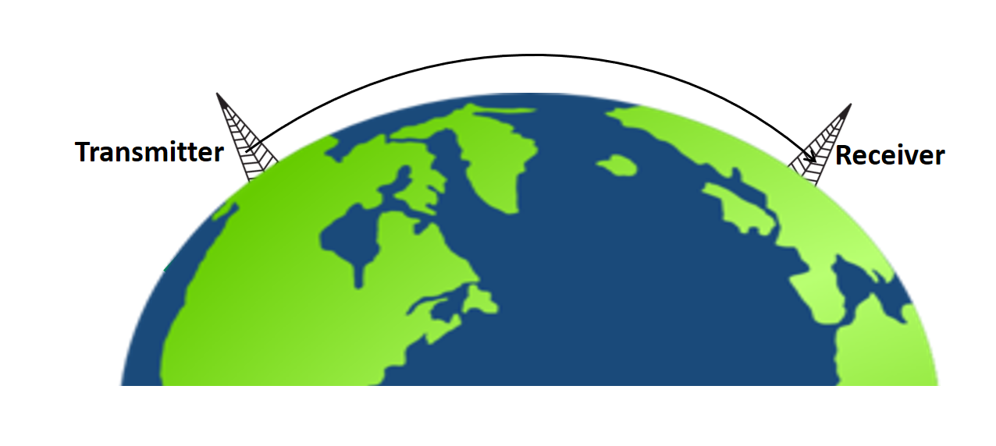

Figure 2 Ground Waves Propagation

**Why the Electromagnetic waves in this frequency band follow the earth’s curvature?**

* Electromagnetic waves induce a current in the earth’s surface due to which it gets slowed down(attenuated) due to absorption near the earth causing the waves to tilt downward and hence follow earth’s curvature
* In this range, the electromagnetic wave is scattered by the atmosphere layers in such a way that they do not penetrate the upper atmosphere
* Diffraction causes waves to bend
* More the frequency, more is the attenuation
* Distance travelled is short
* For high frequency waves, ionospheric propagation is used

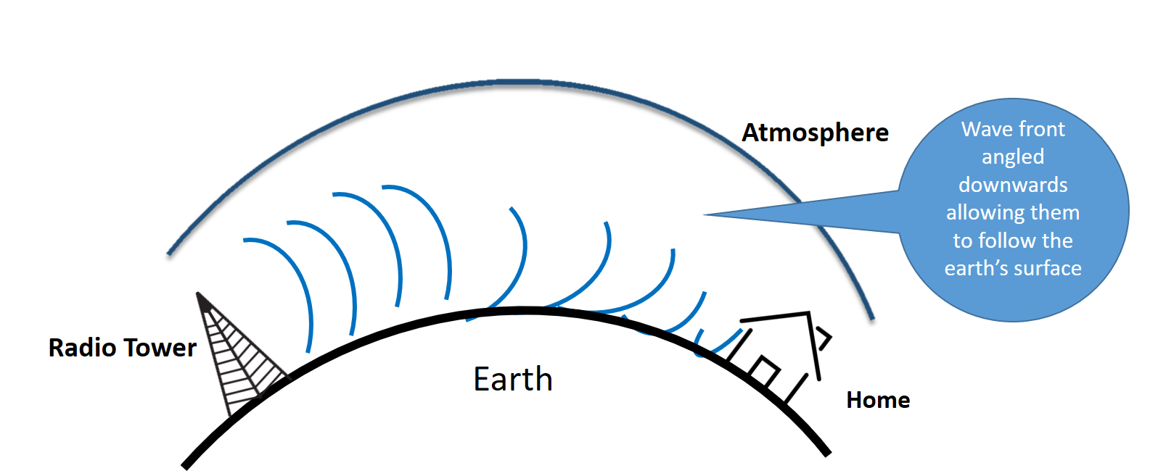

Figure 3

**Factors effecting distance travelled by ground waves**

* Power of Transmitter; If the Power is high, distance covered will be more.
* Frequency of Transmitter; More the frequency, lesser the distance travelled
  + - long distance communication using frequencies below 3 MHz (the earth behaves as a conductor for all frequencies below 5 MHz)
    - short distance communications using frequencies between 3 and 30 MHz
* Condition of earth’s surface
  + - Ground conductivity, terrain roughness and the dielectric constant all affect the signal attenuation
    - ground penetration varies, becoming greater at lower frequencies
* If there are obstructs like buildings, hills, a distance travelled will be less due to attenuation

**Sky Wave Propagation or Ionospheric Propagation (2-30 MHz)**

Atmosphere consists of different layers. When cosmic rays from sun fall on atmospheric layers, atoms get ionised. At higher layers, the density is less; less ions are produced. Solar radiation penetrates that layer and reaches the middle layer. Middle layer is denser; more ions are produced. Radiation penetrates further; but less radiation reaches the lower layers; though denser less ions are produced. Middle layer maximum ionisation; known as Ionosphere. High frequency waves (3-32 MHz) when reaches this layer and gets reflected to the ground station hence covering large distance. Phenomena are similar to total internal reflection in optics. A signal from antenna at a station on earth strikes the ionosphere; It is reflected back down the earth. Sky wave signal bounces back and forth between the ionosphere and earth’s surface and can travel along a long distance across the globe.Used in Amateur radio, CB radio, International Broadcast, BBC, voice of America.

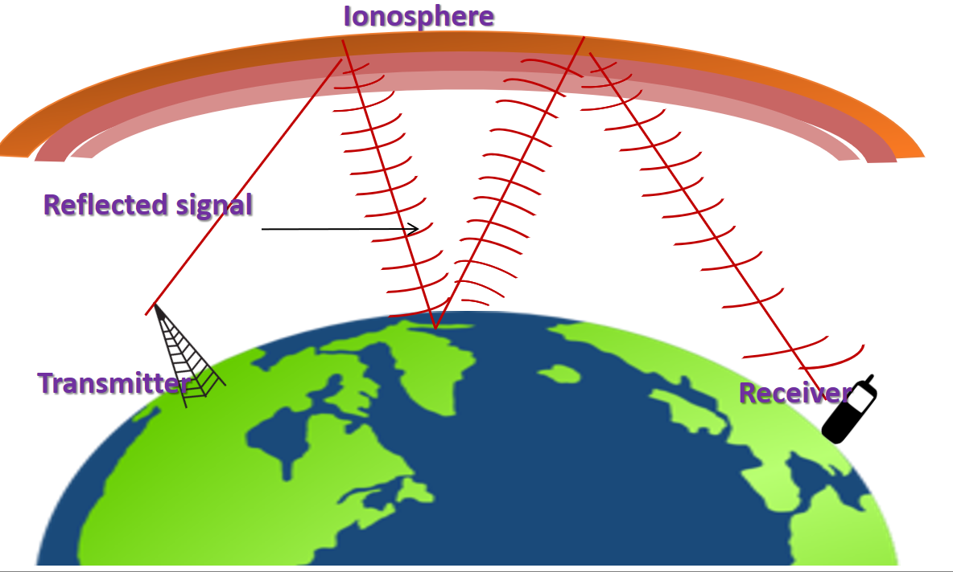

Figure 4 Sky Waves Propagation

Distance traveled by sky waves depends on

**Angle of Radiation:** If the angle of radiation from the transmitting antenna towards sky is travel short distance and if angle of radiation is more, sky waves will travel longer distance

**Strength of Ionosphere:** If the strength of Ionosphere is more, attenuation of waves will be less, (this is how sky wave broadcast travel all over the world) they will travel longer distance and if strength is less, it will offer more attenuation to the sky waves hence they will be received at a shorter distance

**Power of transmitter:** More the power, more the distance from transmitter to receiver

**Level of ionization:** It depends on Level of radiation which decreases with altitude, time of day of year and season. As per the sun condition, the ionization increases and decreases. More the ionization, more the reflection. Therefore, the propagation also changes as per day and night. Frequencies below 10MHz propagation effectively by sky wave at night whereas frequencies above 10 MHz propagate effectively during the day.

**Line-of-sight or Space wave**

The communication follows straight line-of-sight at frequency higher than 40 MHz At this frequency, the signal is not reflected by ionosphere and it penetrates the ionosphere and escape. In satellite communication, this signal straight reaches the satellite overhead and back to the ground station at Earth penetrating layers of atmosphere. For ground based communications, this propagation follows line-of-sight i.e. the transmitter and receiver should be in line-of-sight. Therefore the space wave propagation is also called as **line of sight propagation**.

**Example** satellite communication, FM broadcast, two-way radio, AM aircraft communication, Aircraft navigation aids, cellular phone, radar, microwaves links, cordless phones, all Infrared and optical communications use Line-of-sight Propagation or space wave propagation.

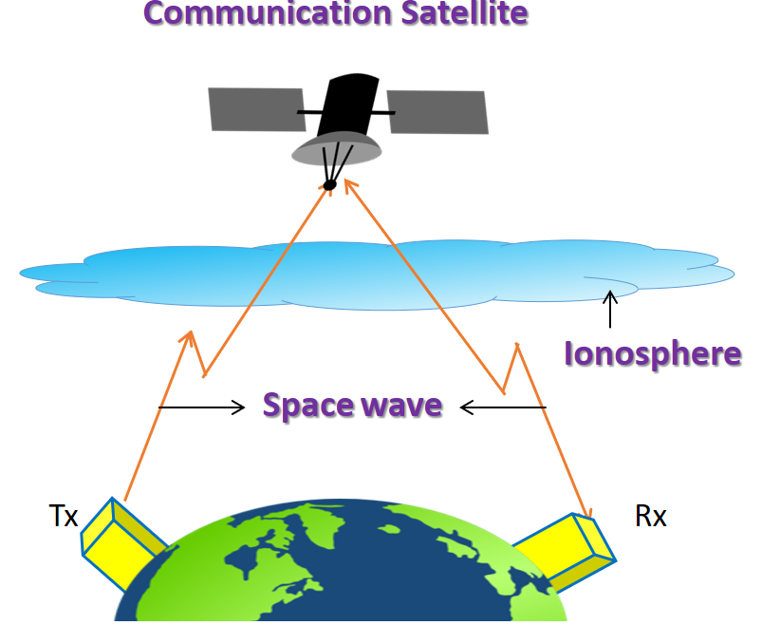

Figure 5 Space wave Communication

## **Factors effecting distance travelled by space waves**

* **Line of sight distance : D**istance between transmitting antenna and receiving antenna at which they can see each other, which is also called **range of communication**
* **Curvature of the earth:** LOS waves gets blocked by curvature of earth

To increase range, the heights of transmitting and receiving antennas should be increased. The height should be above the horizon

If R is radius of the earth, antenna height should be ht =

Maximum LOS distance= +

Where ht and hr are heights of sender and receiving antennas.

**Phenomena effecting signal propagation**

When a signal travels in free space, it behaves like light. It travels straight from sender to receiver. But in real scenario signal in mobile communication, Wi-Fi and other networks have to come across various objects in atmosphere, environment and other surroundings like mountains, buildings, furniture, rain water molecules of atmosphere layer and many others. These objects pose different effects on the propagation of signals namely

* + - Reflection
    - Diffraction
    - Refraction
    - Scattering

As a result the signal received will differ from signal transmitted due to the various transmission impairments caused by these phenomena. For analog signals these impairments degrade quality of signals whereas in digital data they may cause bit errors like a bit changed to 1 or vice versa. In this section we will discuss various phenomena and the object offering them and in next section we will be discussing various effects and impairments caused by them.

**Reflection**

When the propagating signal falls on an object whose size is large as compared to wavelength of the signal it is reflected. For example, surface of earth buildings and walls offer reflection to the propagating signal

For example: A GSM signal whose frequency = 900 MHz; λ = 33 cm; Signal will be reflected by objects of size > 10m. Reflection depends on dielectric properties of objects. If the object is a perfect dielectric some energy will be reflected back, some will be transmitted and there will be no absorption of energy. If the object is perfect conductor all the energy of the signal will be reflected back. For long distance sea is one of the best reflecting surfaces. Desert areas are poor reflector. For short range common’s buildings, metallic surface offer reflects. The strength of reflected signal will be decreased if the medium or the object offers absorption of signal. Though reflection degrades the signal quality, it also helps the signal to reach the points where LOS transmitter cannot reach



Figure 6 Reflection from sea

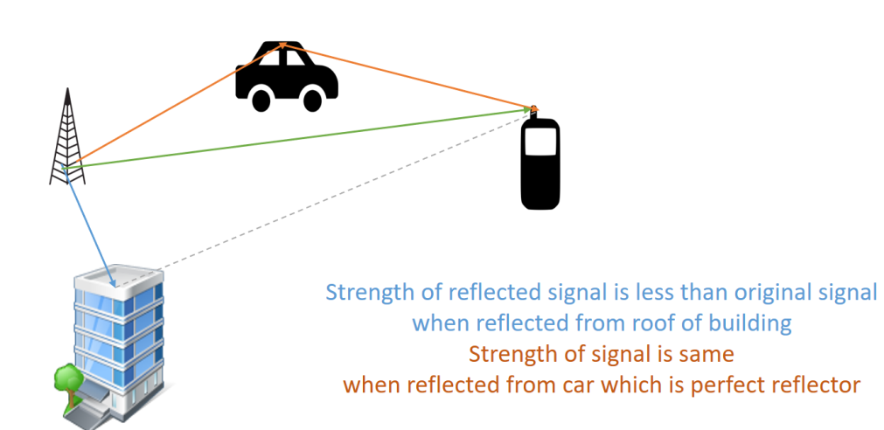

Figure 7 Reflection from different object

**Diffraction**

Diffraction of radio waves is caused by obstructs or surfaces that has sharp irregularities (edge). Corners of buildings, furniture, back of trees all offer diffraction. The phenomena causes bending of radio wave as it passes the edge of the object. It is due to redistribution of energy within a wave front when it passes near the edge of an opaque object and allows radio wave to propagate around corners. Due to this effect, radio signals propagate around the surface of the earth, beyond the horizon and behind the obstructions. Diffraction results in a change of direction of part of the wave energy from the normal line-of-sight path. This change makes it possible to receive energy around the edges of an obstacle. The lower the frequency or the longer the wavelength, the greater the bending of the wave. Radio waves are more readily diffracted than light waves.

Figure 8 Diffraction



**Scattering**

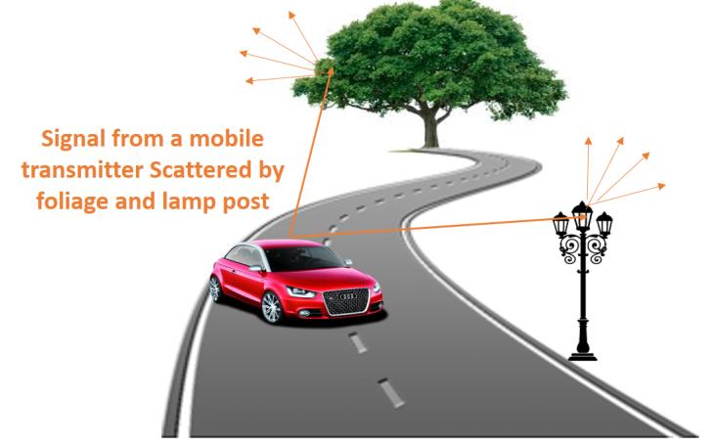When the dimensions of the objects in the path of radio wave are very small as compared to the wavelength of the waves takes place. Example: forage, street signs, lamp posts offer scattering. The incoming signal is scattered into several weaker outgoing signals.

Figure 9 Scattering

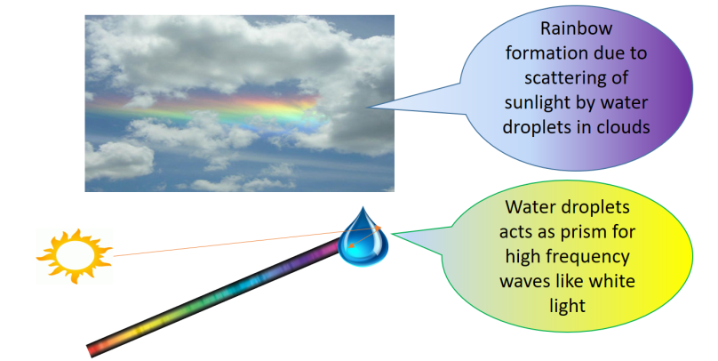For optical light of wavelength of order nanometer, water molecules offer scattering. For example: when sunlight fall a water droplet in the cloudlets it gets scattered into constituent colors – VIBGYOR. Here water droplets act as prism and we see a rainbow.

Figure 10 Scattering

**Transmission impairments**

All these effects have both positive and negative impact on propagation. They help in propagation when there is no clear Line of Sight between sender and receiver. For example: WLAN in office environment, mobile communication in street. at the same time, they also offer some propagation impairments that degrade the quality of signals. All these effects may occur individually or simultaneously and depends on wavelength of wave and also on time. Therefore it is very difficult to interpret or predict the strength of signal at a particular point of time. But it is also necessary to do that in advance to decide the location of antenna, direction of bean and cover age of antenna. Therefore propagation models are used for predicting the average received signal strength at a given distance from transmitter.

Two types of models are used to find the average signal strength over a transmitter received separation distances:

* Large scale propagation model
* Small scale propagation model

If the distance is in hundreds or thousands of meters as in case of mobile physical large scale is used and for short travel distance small scale models are used. The next sections present some transmission impairments and their effects on quality of communication:

**Attenuation**

Attenuation is reduction of signal strength during transmitter. Its unit is decibels It is also known as path loss.

Attenuation

Example If an RF signal transmitted at 10mw encounter a wall which reduces its power to 5mw.

Attenuation =1 =10 * 0.3010=3 decibels

For an ideal isotropic antenna, free space loss is

(Attenuation increase with frequency)

Or

For other antennas, gain of antenna should be considered

Therefore received power depends on

1. Increase frequency of propagation
2. Distance depends between transmission and receiver
3. Depends on gain of transmitting and receiving power in case antenna is not isotropic

**Free Space loss**

Free space propagation the transmitting and receiving antenna are located in an empty environment. The obstacles are absent in such an environment. Radio waves propagate as light does i.e. follow line-of-sight. But even if no matter exists between sender and receiver, the signal experience free space loss. This is the main mode of loss, the strength of the signal falls with increase in distance. This is because for isotropies radiation, there is omni directional propagation i.e. it disperses with distance in the form of a sphere with transmitter as the center. If no obstacles are there, this sphere grows and the sending energy is equally distributed on the surface of the sphere area with radius as the distance from the transmitter equal to 4πd2 . Therefore, signal strength decreases with square of distance from the transmitter.

Example: If the transmitter sends signal of strength at distance of 100m. Then signal strength at 400m (4 times increase distance)

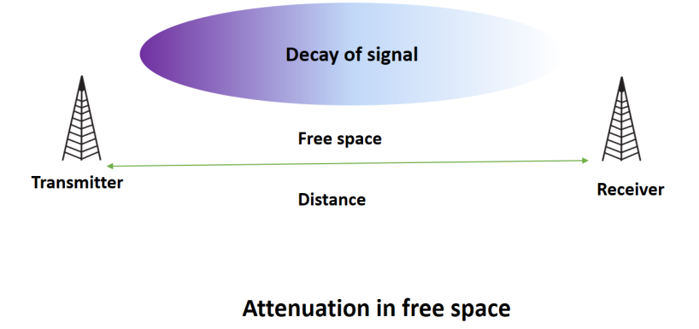

Figure 11 Attenuation in free space

We have discussed that signal strength in free space decreases only as the distance. It behaves very much like light but in real life, the propagation likes in mobile phone, WLAN etc. do not follow line-of-sight. Particularly in urban area there are many objects like buildings, skyscrapers, trees etc. are there. They also affect quality of signal. Besides these atmosphere components likes rain, fog, air, smog influences the propagation. They absorb much of radiation of antenna.

**Blocking or shadowing**

Blocking or shadowing is extreme form of attenuation in which the radio signals are blocked by obstacles. The effect is frequency dependent greater the frequency more it behaves likes light gets obstructed even by small obstacle. Lower the frequency, penetration is more. Long waves can even penetrate through the ocean while small waves can blocked even by a tree. Water vapor and oxygen in the atmosphere attenuates signals in the range of 22GHz. Oxygen absorbs signals of 30GHz – 60GHz frequency. Rain and fog attenuates by scattering. Therefore in the areas of precipitates lower frequency bands should be used. Flat surfaces with dimensions larger than a wavelength often reflection whereas rough surface contribute to scattering.

## **Multipath Propagation**

When the signal travels from sender to receiver through the radio channel, it is reflected, refracted, diffracted or scattered by the objects in the environment like buildings, atmosphere etc in mobile telephony and furniture in WLAN. As a result the signal does not follow line-of-sight and follow different propagation paths in the form of multipath components. Each multipath component travel with different **amplitude, delay and phase shifts** among each other and reach the receiver. In the figure below it can be seen that signal is taking many paths. One is direct line of sight and others are followed after reflection, diffraction and scattering.

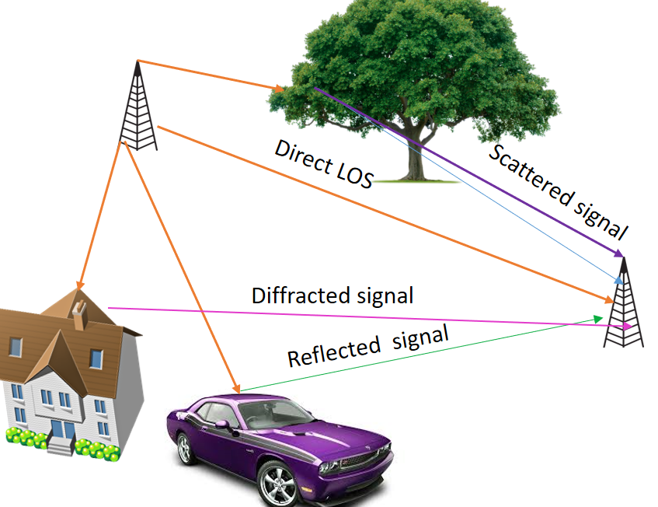

## Figure 12 Multipath Components

## **Delay Spread**

Due to finite speed, multipath components travelling along different paths with different lengths arrive at receiver at different times. Each component may suffer attenuation and arrive with different power. Some may not be detected at all and rejected as noise. This effect is called delay spread. In cities delay spread is 3 to 12 micro sec. GSM can tolerate upto 16 micro sec delay spread. It can be seen in Fig. that 3 signals have arrived the receiver at different times with different power.

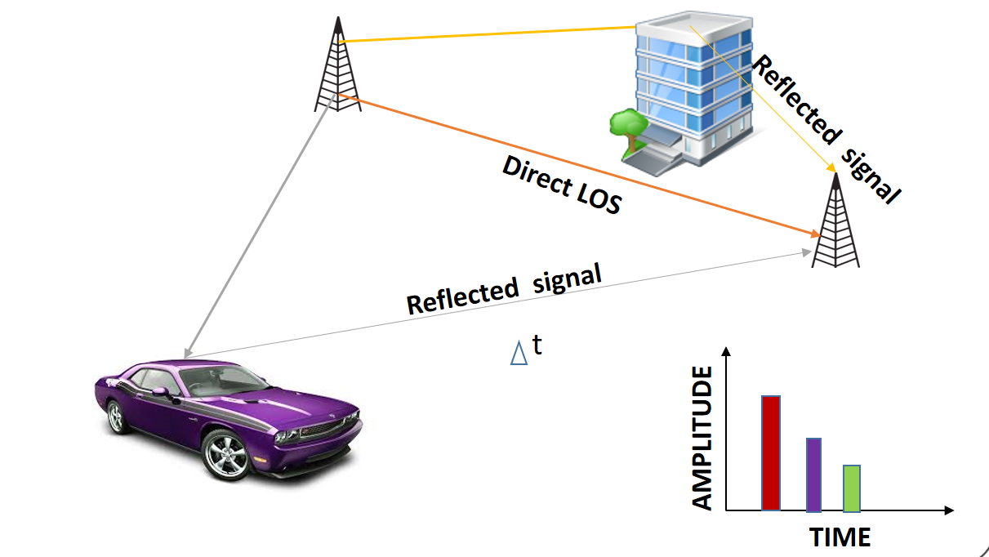

Figure 13 Delay Spread

## **Inter Symbol Interference**

Each multipath component arrive the receiver as a sequence of pulses with different time, amplitude and phase called Inter symbol interference. This effect occurs when data is being transmitted. In the Fig. symbols s1, s2, s3, s4 are transmitted. At first path, there is no delay. In second path, there is delay of one symbol period. In there it is of two symbol periods.

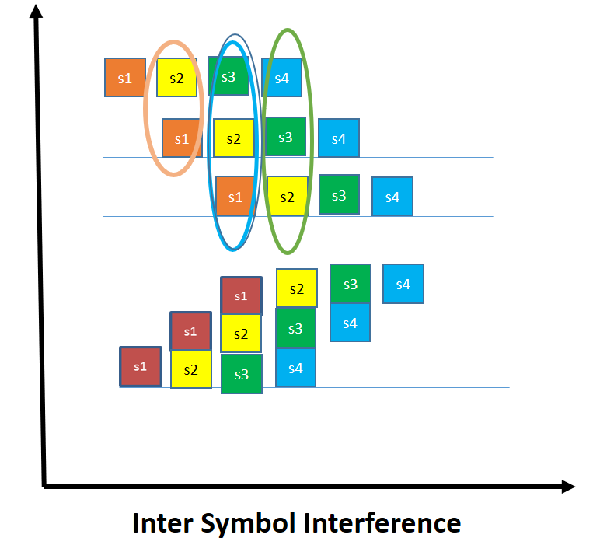Therefore, at receiver, the symbols interfere as shown in figure.

Figure 14 Inter symbol Interference

**Interference of multipath components**

When multipath components with different power arrive at the receiver in phase with each other, they add constructively and phenomena is known as **constructive interference**. Resultant power is sum of powers of individual components.



Figure 15 Constructive interference

When multipath components with different power arrive at the receiver out of phase with each other, they add destructively and phenomena is known as destructive interference. Resultant power is difference of powers of individual components known as fading.

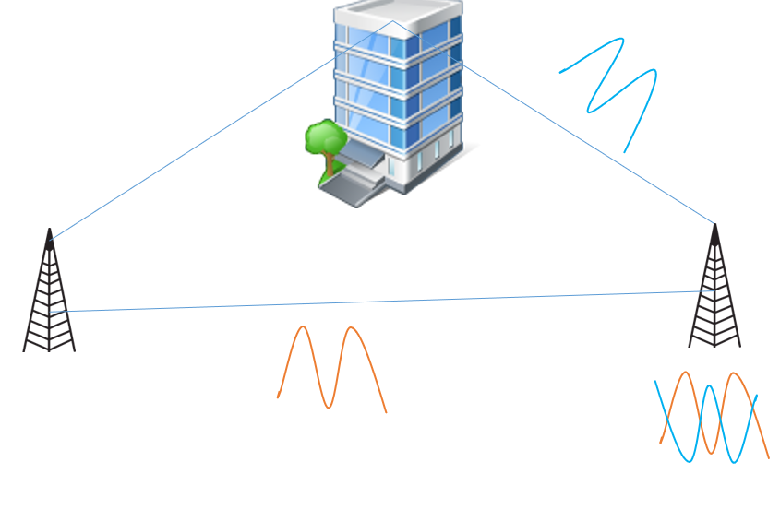

Figure 16 Destructive Interference

## **Solutions for Multipath propagation**

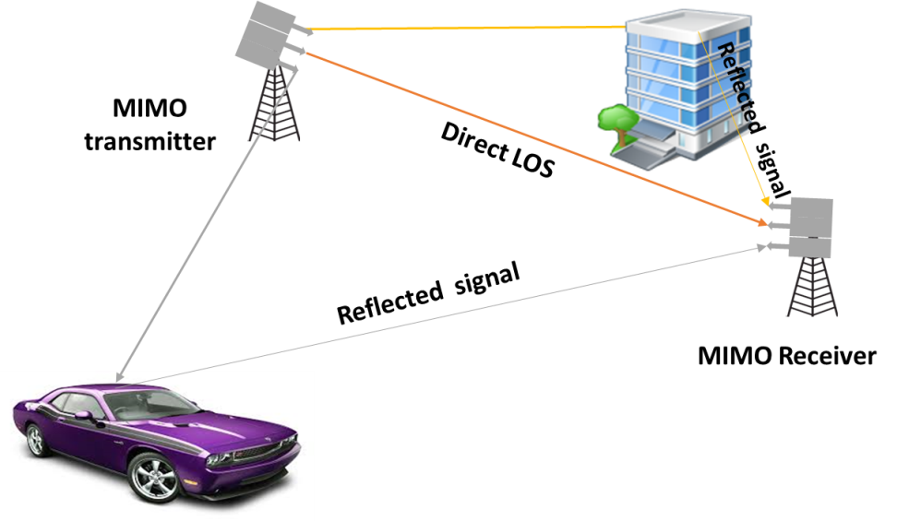MIMO and OFDM are the solution multipath problem. OFDM signals can be made orthogonal to each other so that they do not interfere. It is used by 802.11n, Wi-Fi, LTE-advanced, Wimax and many more technologies. MIMO is a technology which uses multiple antennas to setup multiple data streams on the same channel to increase its capacity. It takes advantage of multipath propagation in providing additional capacity to the channel

Figure 17 MIMO